UM study explores how stem cells can help burn victims
BY AUDRA D.S. BURCH ABURCH@MIAMIHERALD.COM 01/25/2015 3:43 PM

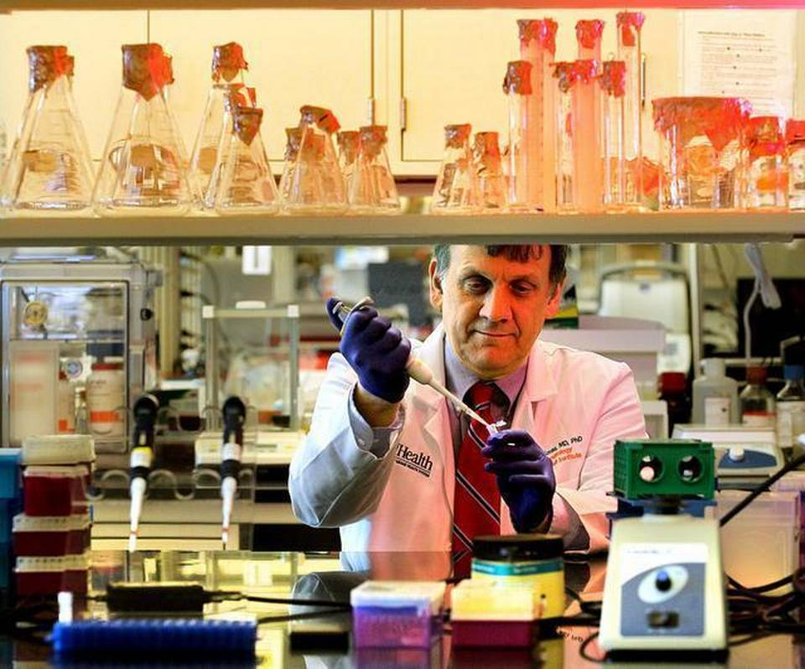Dr. Evangelos Badiavas, principal investigator at the Interdisciplinary Stem Cell Institute at the Miller School of Medicine, University of Miami works in his lab. PATRICK FARRELL MIAMI HERALD STAFF
In a Miami hospital room and a research lab a few buildings away, doctors conducting stem cell clinical trials are trying to change the way burn victims are treated — including military personnel injured in the line of duty.
A pair of University of Miami doctors are conducting the research, funded by the Department of Defense, to develop new therapies using donor stem cells to restore tissue and reduce long-term scarring from burns. The treatment, if successful, could revolutionize burn care by decreasing the need for reconstructive skin graft surgery.
“This is exciting stuff when you think of how helpful it could be. There has been little major advancement in burn treatment in the last 20 years,’’ said Dr. Evangelos Badiavas, principal investigator at the Interdisciplinary Stem Cell Institute at UM’s Miller School of Medicine. “Severe burns can ruin a life, so there is a desperate need.’’
The wars in Iraq and Afghanistan have produced a class of veterans who survived but are left with burn-related injuries. Commonly caused by improvised explosive devices, or IEDs, burns account for 5 to 20 percent of combat injuries, according to a U.S. Army spokesman. And in the civilian world, about 450,000 patients receive hospital and emergency-room treatment for burns annually, according to the American Burn Association.
“The benefit of this therapy would be to have an ‘off the shelf’ technology available for the treatment of deployment-related burn injuries which would not require skin grafting,” said Dr. Wendy Dean, medical adviser for the Tissue Injury and Regenerative Medicine Program Management Office at the U.S. Army Medical Materiel Development Activity. “One of the most urgent requests from both burn patients and their care providers is to eliminate the need for skin grafts.’’
Patients participating in the trial will come from The University of Miami/Jackson Memorial Burn Center, most with deep, second-degree burns. For the trial, the wound is typically covered in a thin, protective dressing. Mesenchymal stem cells, adult cells harvested from the donor’s bone marrow, are then injected underneath the coating into the wound to regenerate the outer and inner skin layers.
Patients will receive treatments every two weeks. How many treatments are needed to rebuild the skin is a central question of the trial. Other questions they hope to answer by the end of the two-year study period: How long does the wound actually take to completely heal with a new layer of skin? What is the probability of stem cell rejection? Who are the best candidates for the treatment?
The mesenchymal stem cells are cultivated in the lab for about four to six weeks then stored in a freezer at minus-80 degrees until they are used for treatment.
As burns heal, doctors must consider physical appearance and function — if the skin stretches normally and has full range of motion over joints — plus quality of life, which is related to itching, temperature regulation and pain.
“The trial is extremely exciting because right now, we have very little to offer patients with deep second- and third-degree burns, other than skin grafting,” said Dr. Carl Schulman, director of UM’s William Lehman Injury Research Center, who is working with Badiavas on the trial. “We are hoping to modulate the healing process, make the wounds heal better. The hope is that on the deeper wounds, with this treatment, we can avoid surgery or reduce the scarring.”
The trial was a natural next step of Badiavas’ interest in stem cells. A dermatologist, Badiavas researched the function and applications of stem cells at Brown University, including a clinical trial in 2003. He came to the University of Miami — his second stint at the school — five years later.
“I was always interested in bone marrow stem cells and the fact that a single bone marrow stem cell can produce all the blood cells in the body, so it has this capacity for regeneration,” he said. “Experimentally, you can take a single stem cell and reconstitute an entire blood system. ... Several years ago, I had a suspicion that these stem cells can do more than just reconstitute bone marrow.”
With that in mind, Badiavas designed an experiment conducted at the Roger Williams Medical Center that explored how bone marrow stem cells can be used to regenerate damaged tissue. For the study, they worked with patients whose wounds, including leg ulcers and pressure sores, had not healed within a year.
“We saw some healing in all the patients but it was a long process. In some cases, it took up to a year. Deep, complicated wounds healed in a depressed scar and the scarring was remarkably less,’’ Badiavas said. “We learned that the stem cells could rebuild tissue. Now it’s a matter of seeing how it works with burn wounds.”

